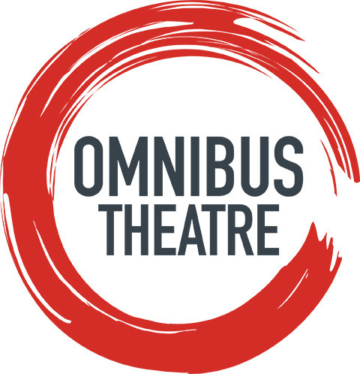
PRESS RELEASE
APRIL 2018
DEVIL MAY CARE
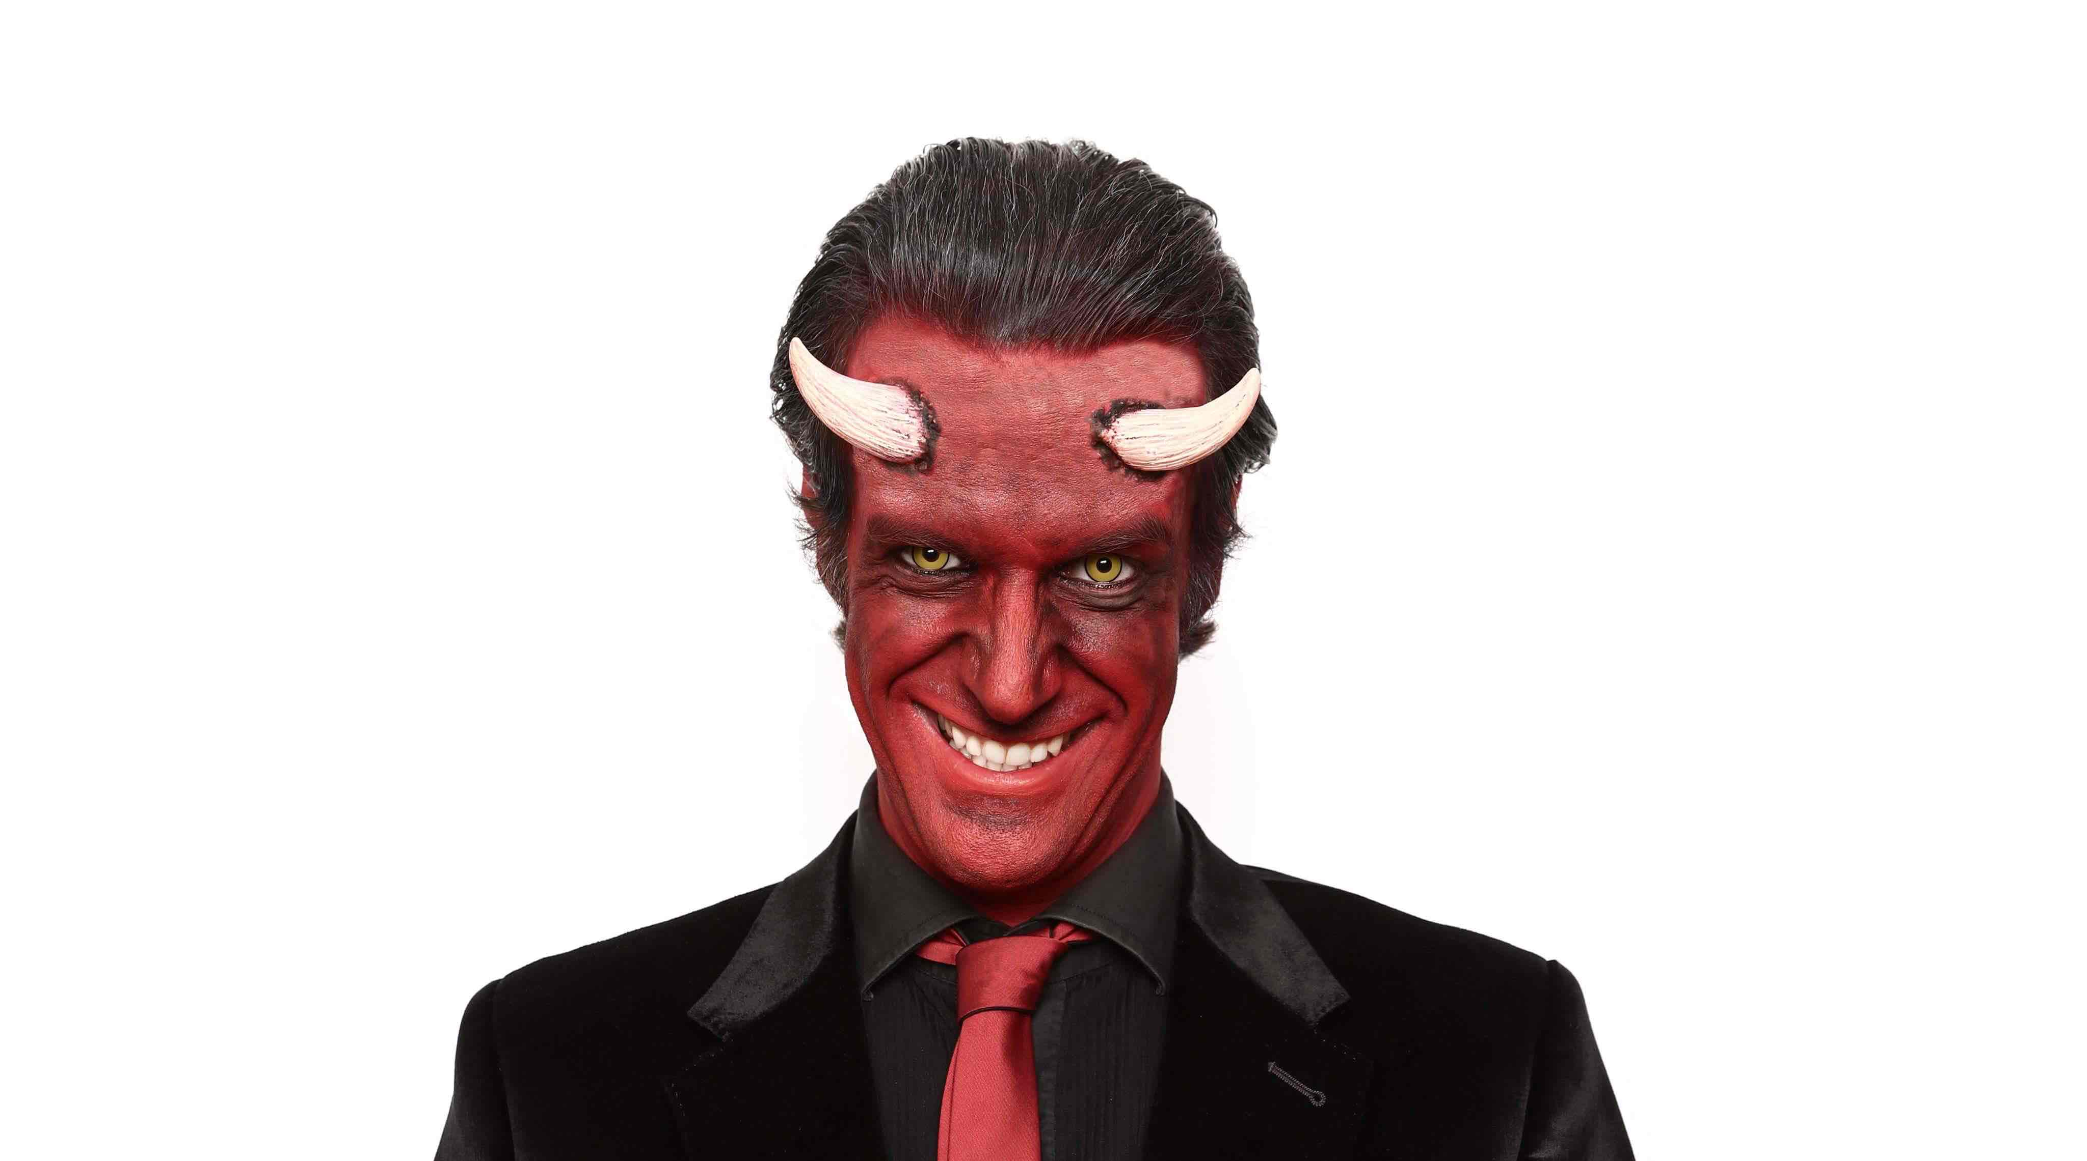

Marcus Brigstocke premiere’s his first character-driven stand up show
25-29th July at Omnibus Theatre

Snowflake, Nazi, Remoaner, Trot, Libtard, Brextremist, Feminazi, Piers Morgan…
As we divide each other up into more and more unpleasant categories of evil, it is time to establish, once and for all, what is good and what is bad.

Who better to arbitrate in these challenging divisive times than Lucifer himself? The Devil no longer runs Hell day to day. He’s retired now, and plays Golf at Mar-a-Lago, but the Dark Lord is still on the board of The Underworld and attends a bi-annual meeting to advise on how to make eternal damnation sustainably hot, how to keep a thousand minions on a zero hours contract and what to do about Jacob Rees Mogg.

This exclusive five-day run will give Londoners the opportunity to see Marcus Brigstocke’s new show ‘Devil May Care’ before he heads up to the Edinburgh Festival Fringe followed by a national tour.

This will be the first time Brigstocke presents a ‘character driven’ stand-up show, performing as Milton’s fallen angel Lucifer from ‘Paradise Lost’. Marcus says: “I’ll be fully devilled up, complete with horns, tail and malevolent grin. I want to explore the nature of good and bad. Do good people do bad things with good intentions? Is anyone truly wicked? Are any of us wholly good? What’s to be done about Piers Morgan?”

Brigstocke is a master of satirical comedy with an impressive list of TV credits including his role as a team captain on Argumental (Dave), and host of The Late Edition and I’ve Never Seen Star Wars (BBC4). Other appearances include; Live At The Apollo (BBC1), Have I Got News For You (BBC1), Mock the Week (BBC2), QI (BBC2), Sorry I’ve Got No Head (BBC1), The Late Edition (BBC4), and the 11 O’Clock Show (Channel 4).

BBC Radio 4 has become somewhat of a second home to Marcus with regular appearances on I’m Sorry I Haven’t A Clue, The Now Show and Just A Minute; he has also written and recorded three series and four specials of his hit show Giles Wemmbley-Hogg Goes Off. Most recently he co-wrote and co-starred in the new BBC Radio 4 sitcom The Wilsons Save The World.

‘…charming, hilarious and utterly refreshing…don’t miss this incredible show’ – Sunday Mirror

‘Sharpest one-liner merchant’ – Sunday Times

‘Rare is the stand-up show that makes you laugh, think and then fight back the tears. This is it.’ **** - The Daily Telegraph

‘if you haven’t seen him live, then you haven’t seen him at his very best’ ***** - The Mirror

Devil May Care headlines Omnibus Theatre’s Edinburgh Previews, from 15 – 29 July, which also includes Sisterhood, The Rockford File and Gullivers Travels.

Listings information:
Devil May Care
Produced by Off-The Kerb Productions
Wed 25 – Sun 29 July, 7.30pm. See website for more details.
Ticket prices £9, £7 conc.
14+ years old

Devil May Care Tour Dates: 6 Sept – 1 Dec. See website for more details. http://www.marcusbrigstocke.com

Box Office: Tel: 020 7498 4699, Email: boxoffice@omnibus-clapham.org
Online: www.omnibus-clapham.org
Omnibus Theatre, 1 Northside, Clapham Common, London, SW4 0QW
Twitter: @Omnibus_Theatre
Facebook: @OmnibusTheatre
Instagram: omnibus_theatre

Press enquiries: diana.whitehead@omnibus-clapham.org. Tel: 07939 149887
- ENDS -

NOTES TO EDITORS
About Marcus Brigstocke - one of Britain’s finest comedians and broadcasters, Brigstocke starred as King Arthur in the West End and on a fantastically successful nationwide tour of Spamalot. His talent was noted early on in his career in 1996 when he won the BBC New Comedian Award at the Edinburgh Festival. He is now regarded as a major comedy, writing and acting talent, performing stand up nationally to sell out audiences both on tour and on the well-trodden comedy circuit. BBC Radio 4 has become somewhat of a second home with The Brig Society, I’ve never seen Star Wars and regular appearances on The Unbelievable Truth, The Now Show and Just A Minute; Brigstocke has also written and recorded three series and four specials of his hit show Giles Wemmbley-Hogg Goes Off. TV credits The Joy Of Techs, I’m sorry I’ve got no head, Argumental (DAVE), and host of The Late Edition and I’ve Never Seen Star Wars (BBC FOUR). Other appearances include; Have I Got News For You (BBC ONE), QI (BBC TWO), The Late Edition (BBC FOUR), and the 11 O’Clock Show (Ch 4).

About Omnibus Theatre - Housed in a former Victorian library in London and inspired by the building’s literary heritage, we provide vital support for emerging artists to create new work within the building. Omnibus was a recipient of the Peter Brook/Royal Court Theatre Support Award in 2016. Notable in-house productions include Offie winning Zeraffa Giraffa (2017), Spring Offensive (2017), Mule (2016), Macbeth (2014), Woyzeck (2013), Colour (2015). A registered charity, Omnibus Theatre is led by Artistic Director Marie McCarthy, our patrons are Sir Michael Gambon, Matthew Warchus, Sir Richard Eyre and Maggi Hambling CBE.

